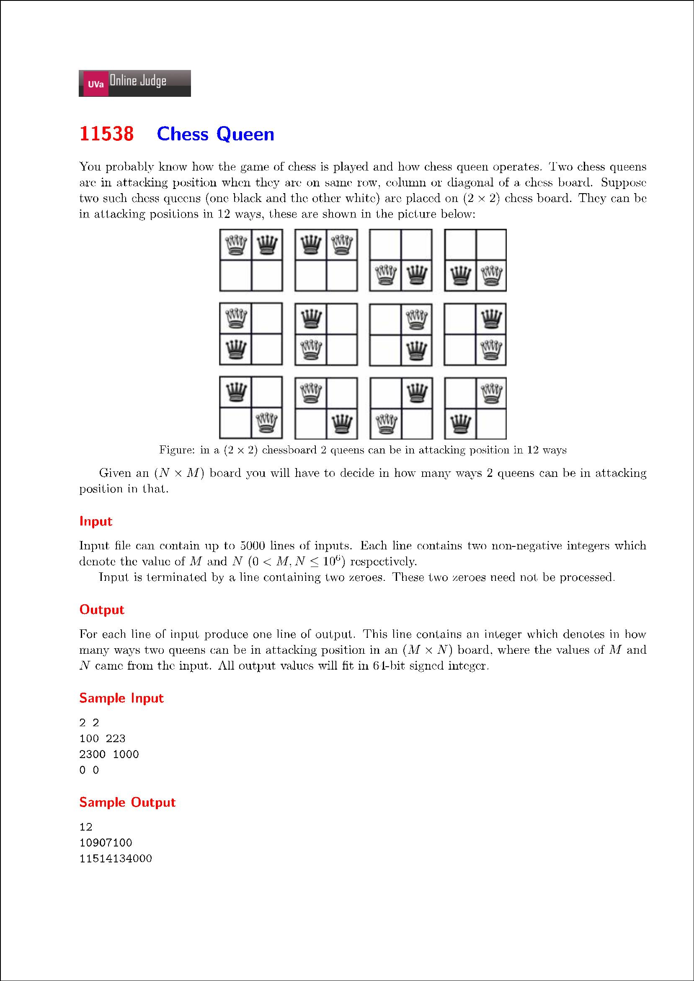

2 2

100 223

2300 1000

1234 5678

7777 88888

1 999999

999999 2

999999 999999

0 0

12↵\r\n

10907100↵\r\n

11514134000↵\r\n

64441649372↵\r\n

77258629337736↵\r\n

999997000002↵\r\n

1999999999994↵\r\n

3333319333351999992↵\r\n